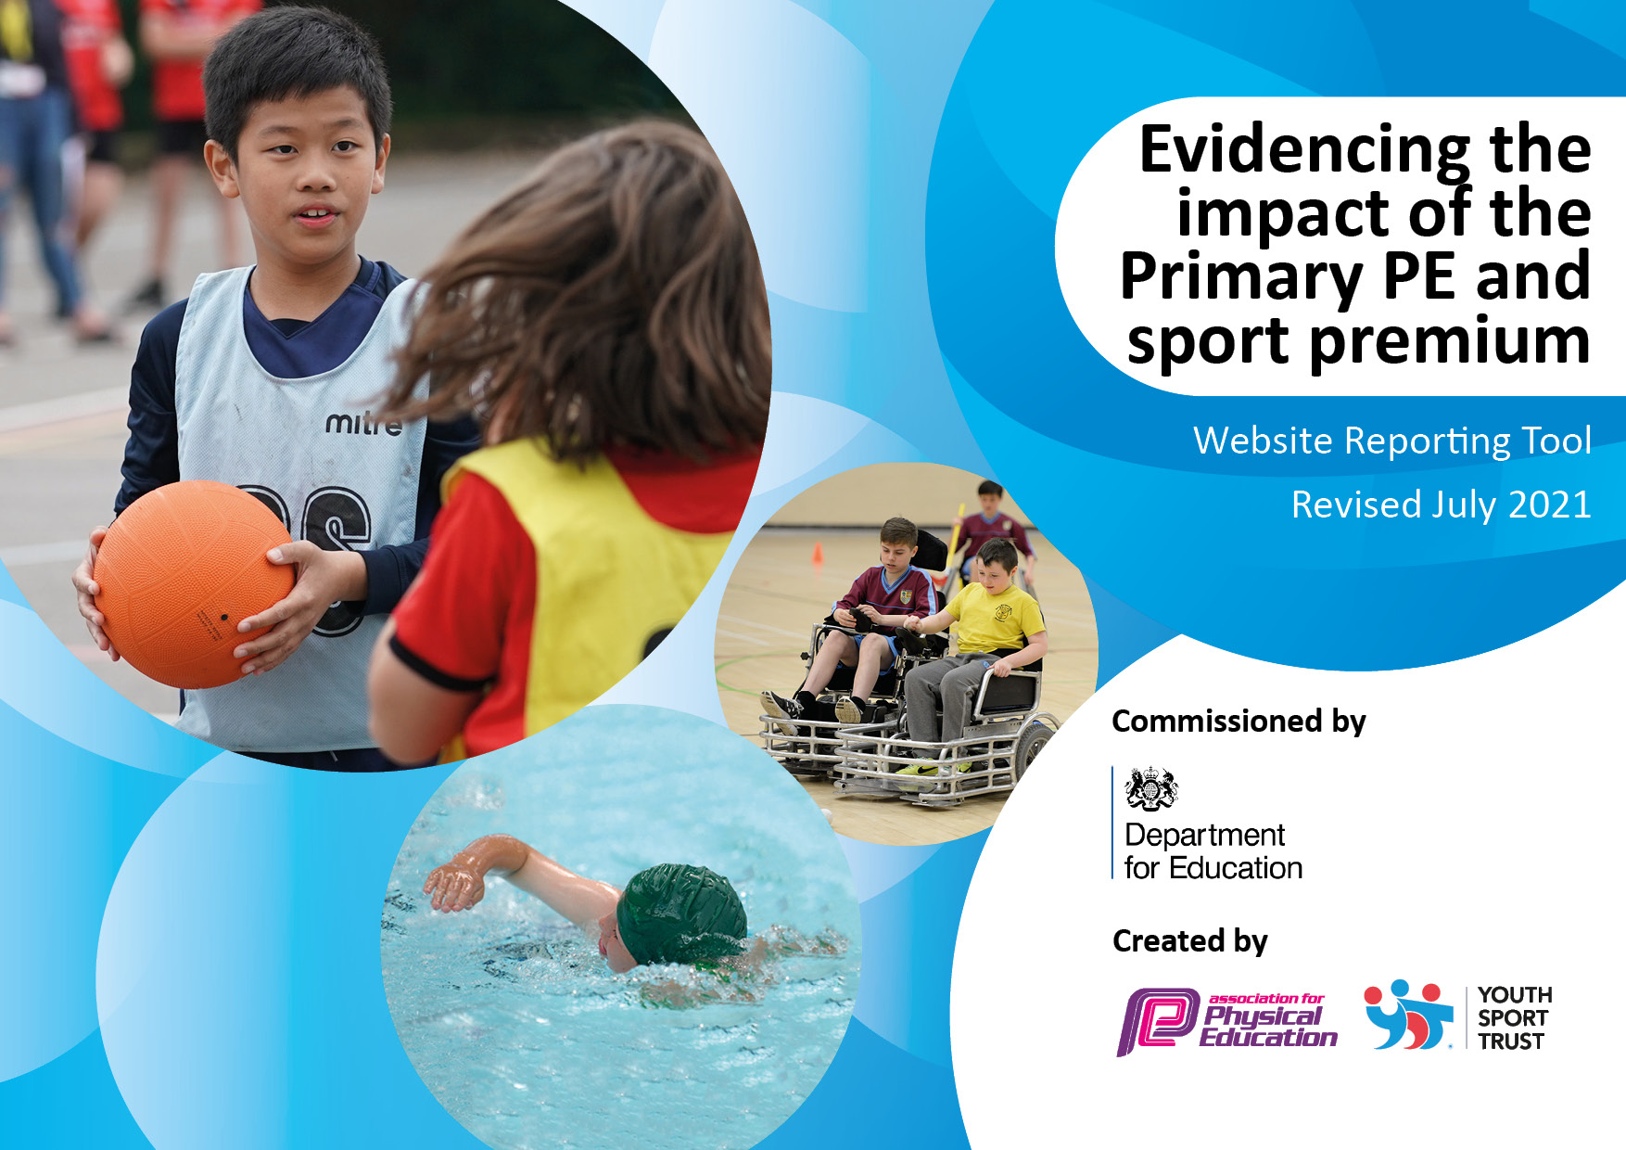
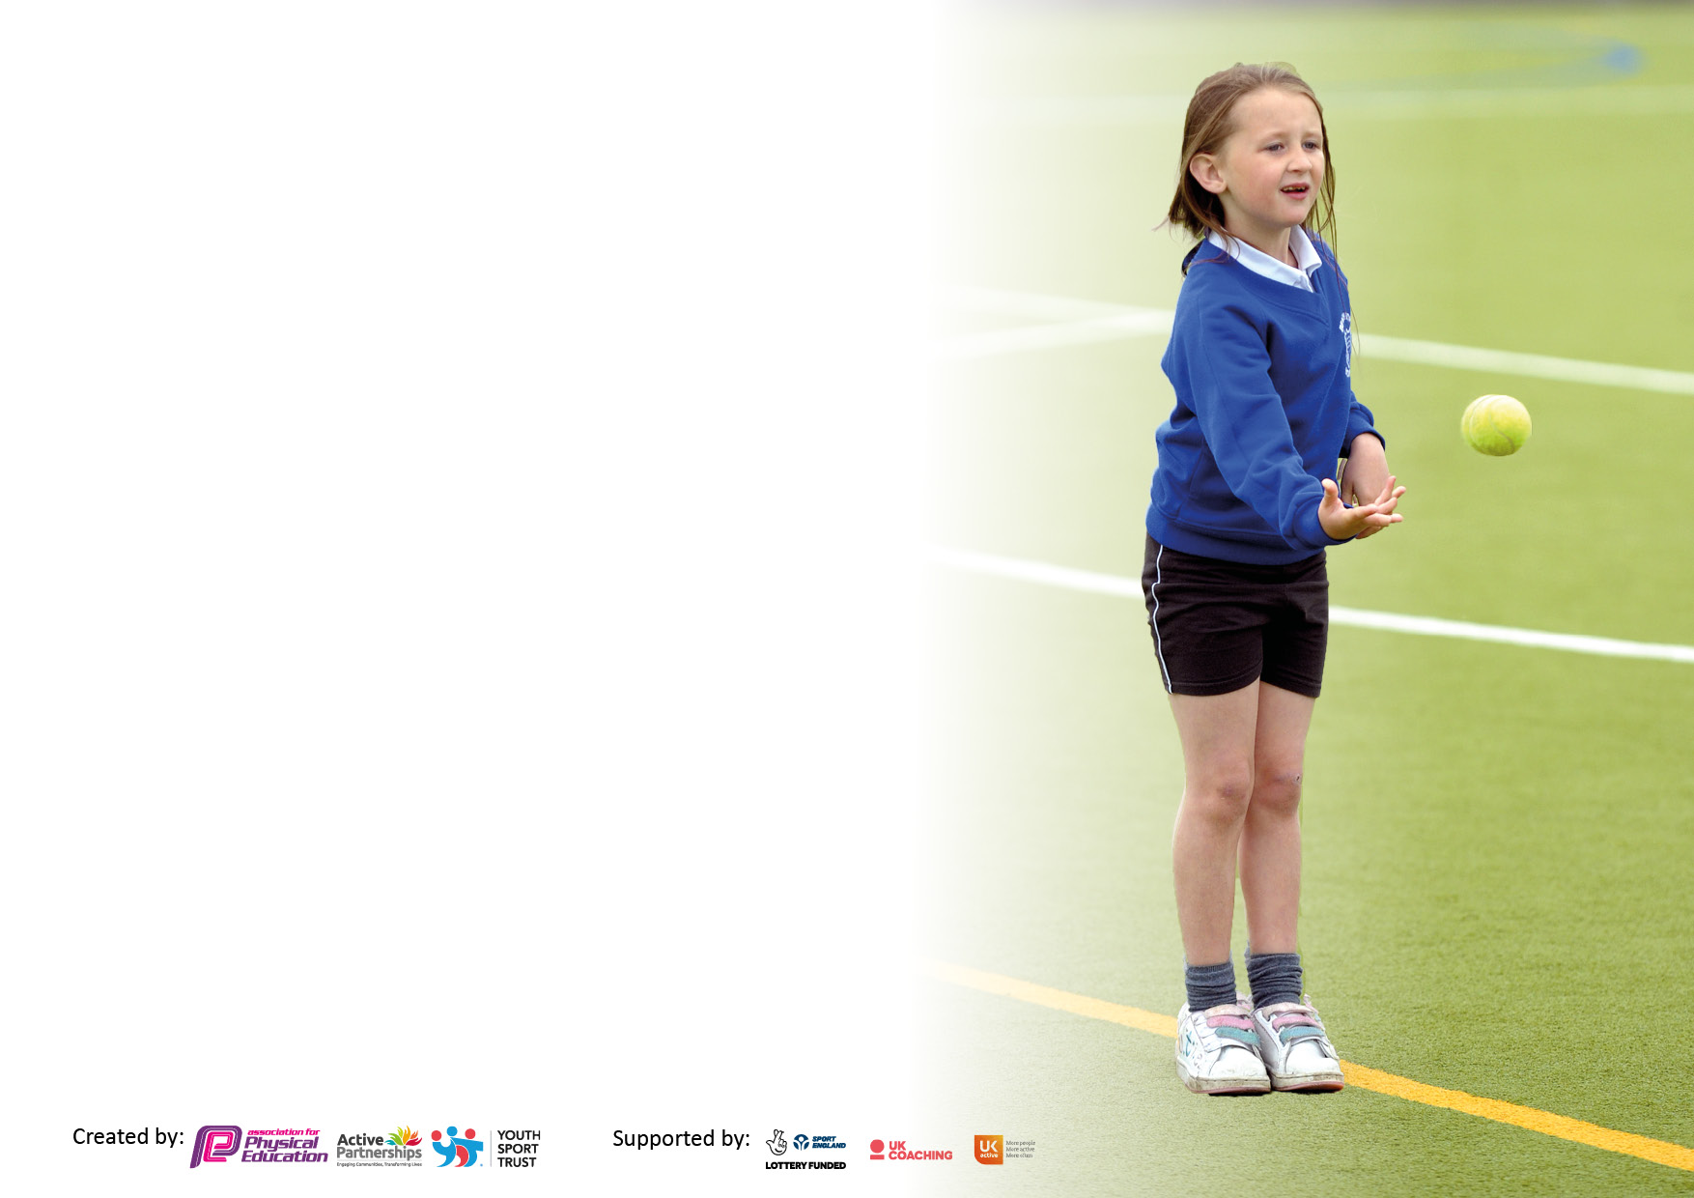

It is important that your grant is used effectively and based on school need. The Education Inspection Framework makes clear there will be a focus on ‘whether leaders and those responsible for governors all understand their respective roles and perform these in a way that enhances the effectiveness of the school’.

Under the Quality of Education Ofsted inspectors consider:
Intent - Curriculum design, coverage and appropriateness
Implementation - Curriculum delivery, Teaching (pedagogy) and Assessment
Impact - Attainment and progress

To assist schools with common transferable language this template has been developed to utilise the same three headings which should make your plans easily transferable between working documents.

Schools must use the funding to make additional and sustainable improvements to the quality of Physical Education, School Sport and Physical Activity (PESSPA) they offer. This means that you should use the Primary PE and sport premium to:

- Develop or add to the PESSPA activities that your school already offer
- Build capacity and capability within the school to ensure that improvements made now will benefit pupils joining the school in future years
- The Primary PE and sport premium should not be used to fund capital spend projects; the school’s budget should fund these.

Pleasevisitgov.ukfortherevisedDfEguidanceincludingthe5keyindicatorsacrosswhichschoolsshoulddemonstrate animprovement.Thisdocumentwillhelpyoutoreviewyourprovisionandtoreportyourspend.DfEencouragesschools to use this template as an effective way of meeting the reporting requirements of the Primary PE and sport premium.

We recommend you start by reflecting on the impact of current provision and reviewing the previous spend.

Schools are required to publish details of how they spend this funding, including any under-spend from 2019/2020, as well as on the impact it has on pupils’ PE and sport participation and attainment. All funding must be spent by 31st July 2022.

We recommend regularly updating the table and publishing it on your website throughout the year. This evidences your ongoing self-evaluation of how you are using the funding to secure maximum, sustainable impact. Final copy must be posted on your website by the end of the academic year and no later than the 31st July 2021. To see an example of how to complete the table please click HERE.

Details with regard to funding
Please complete the table below.

Total amount carried over from 2019/20 | £1,385
Total amount allocated for 2020/21 | £16
How much (if any) do you intend to carry over from this total fund into 2021/22? | £1,401
Total amount allocated for 2021/22 | £19,190
Total amount of funding for 2021/22. To be spent and reported on by 31st July 2022. | £20,591
Swimming Data
Please report on your Swimming Data below.

Meeting national curriculum requirements for swimming and water safety.  N.B. Complete this section to your best ability. For example you might have practised safe self-rescue techniques on dry land which you can then transfer to the pool when school swimming restarts.  Due to exceptional circumstances priority should be given to ensuring that pupils can perform safe self rescue even if they do not fully meet the first two requirements of the NC programme of study | 17%
What percentage of your current Year 6 cohort swim competently, confidently and proficiently over a distance of at least 25 metres?  N.B. Even though your pupils may swim in another year please report on their attainment on leaving primary school at the end of the summer term 2020.  Please see note above | 17% at Christmas. Additional lessons to be carried out for particular children in summer term.  6G:6  6W:4
What percentage of your current Year 6 cohort use a range of strokes effectively [for example, front crawl, backstroke and breaststroke]?  Please see note above | 17%
What percentage of your current Year 6 cohort perform safe self-rescue in different water-based situations? | 17%
Schools can choose to use the Primary PE and sport premium to provide additional provision for swimming but this must be for activity over and above the national curriculum requirements. Have you used it in this way? | Yes/No

Action Plan and Budget Tracking
Capture your intended annual spend against the 5 key indicators. Clarify the success criteria and evidence of impact that you intend to measure to evaluate for pupils today and for the future.

Academic Year: 2020/21 | Total fund allocated: £19,190 | Date Updated: 13.12.2021
Key indicator 1: The engagement of all pupils in regular physical activity – Chief Medical Officers guidelines recommend that primary school pupils undertake at least 30 minutes of physical activity a day in school |  |  |  | Percentage of total allocation:
 |  |  |  | 20%
Intent | Implementation |  | Impact
Your school focus should be clear what you want the pupils to know and be able to do and about  what they need to learn and to  consolidate through practice: | Make sure your actions to achieve are linked to your intentions: | Funding allocated:  £3,750 | Evidence of impact: what do pupils now know and what can they now do? What has changed?: | Sustainability and suggested next steps:
Increase number of pupils participating in physical activity during after school clubs.  Targeting girls, pupil premium children and pupil voice requests. | Encourage school staff to take on OSH provision from during 2021-2022. School staff to work alongside KSSP/community club to deliver in future.  KSSP coach delivers 3 hours of weekly clubs.  KDDK dance and gymnastics clubs to continue for whole year. | £3,750 KSSP subscription  £2,340 KSSP coach OSH  £1,248 for academic year | Staff will have attended courses from KSSP, shadowed KDDK and now feel more confident to deliver clubs.  87 children from Y1-Y6 attended OSH clubs. Engaging a high proportion of girls and pp children.  Girls attending autumn term OSH clubs: 46/87  PP children attending autumn term OSH clubs: 40/87  Dance clubs are over-subscribed and enjoyed by a range of year groups, especially girls and pp children.  Girls: 11/16  Pp: 6/16 | For more staff to take a physical activity OSH club.  To continue to offer 3 weekly clubs to a range of children, targeting pp and less active children.  To deliver to other year groups, to deliver gymnastics club.  Staff member to join in and learn from the dance teacher for future delivery.  Children who attend have experience performing for an audience, following lifting of covid restrictions.
Maintain the number of opportunities for all pupils to participate in active 30 minutes by improving the lunchtime program. | Lunchtime supervisor staff to work alongside the PE Coordinator and KSSP coach to deliver active lunchtimes.  KS1 and KS2 Playleaders have been trained as part of KSSP subscription.  Increase provision of PA and sports at lunchtimes. KSSP coach delivers 3 weekly 30 minute lunchtime sessions, targeting less active children.  Sports crew to be created in Summer term 2 and to meet regularly to discuss and plan lunchtime provision.  Staff to be trained in utilising an active classroom. Taking place in Summer 2022. | Training and resources are included in KSSP subscription £3,750  £1,170 KSSP coach delivering at lunchtimes. | Raised awareness across school with Active 60 and personal challenges.  This has increased awareness of times of low activity across the school.  Playleaders have developed leadership skills. 26 children, 15 girls, 14pp. They are now able to deliver activities with the lunchtime equipment available.  The same resources can be used in the future.  This has been in more demand compared to last year due to increased awareness of Active 60.  Staff confidence will be increased to deliver active classroom activities to target the inactive times of the day. Children will be given brain breaks, more contribution to Active 60 minutes. Wellbeing and awareness of Active 60 will be increased throughout school. | To continue to support lunchtime staff to deliver activities using resources from KSSP to build confidence alongside playleaders.  Resources ready to be used – activities, personal challenge cards and active 60 posters.  To follow up with staff and sports crew to develop further and create new challenges. Feedback/photos/particular staff member who has done it well can support others.  Playleaders to document participation and enjoyment. Leadership training and peer delivery. Play leaders are to train other year groups in Summer term to target children in all year groups.  Provision to continue to allow all children to access 30 active minutes.
Key indicator 2: The profile of PESSPA being raised across the school as a tool for whole school improvement |  |  |  | Percentage of total allocation:
 |  |  |  | 3%
Intent | Implementation |  | Impact
Your school focus should be clear what you want the pupils to know and be able to do and about  what they need to learn and to  consolidate through practice: | Make sure your actions to achieve are linked to your intentions: | Funding allocated:  £450 | Evidence of impact: what do pupils now know and what can they now do? What has changed?: | Sustainability and suggested next steps:
Raising the profile of PE and Sport to engage more pupils in competition and Physical activity – targeting Pupil Premium and Girls. | Awards via certificates for the School Games Values to be given out at OSH clubs and lunchtimes by playleaders. Playleaders to update PE board and pass onto school.  Continue to promote awards from Community and in school competitions.  Intra-school competitions to be uploaded to school dashboard with SGV awards.  Sports Crew to work alongside playleaders in raising the profile of PE in school. Sports Crew to be trained by KSSP. | £3,750 KSSP subscription  £2,340 KSSP coach OSH | All children and staff have increased awareness of the School Games Values and how to show them.  Increased awareness of the importance of being active outside of school.  Increased opportunity for competition and enjoyment of sport. Children have experience of competition in a comfortable environment.  More children will develop their leadership skills and sense of responsibility. | To support staff to plan end of unit intra events that develop the SG Values further.  To continue to raise awareness of SG values.  To start in Summer 2022.  Crew are to plan games (to be taught in PE lessons), take on different roles (admin/media etc) and raise profile of PE throughout school.
Continue to improve quality and provision of PE lessons within school | Staff to continue to deliver high quality PE lessons and ensure relevant training is provided. PE Hub subscription ***. PE coordinator to work with staff to develop the provision of PE in school.  Staff to be trained by KSSP in the delivery of high quality gymnastics lessons.  Utilise team teaching from KSSP to build skills and confidence of staff.  Wake and Shake introduced into classrooms, classroom yoga and dancing encouraged to be used regularly throughout the day, particularly if not a PE day or if it has been wet play. | £450 PE Hub  £3,750 KSSP subscription | Increased confidence of staff to deliver high quality PE lessons.  Increased.  To increase staff confidence and support their teaching of gymnastics.  Participation and enjoyment increased, new experiences for children and for staff to learn from KSSP. CPD that staff will pass on to others.  Staff and children awareness of PA for wellbeing increased. | PE coordinator to continue to offer PE CPD for staff.  Teachers to deliver a gymnastics unit by the end of the year.  Super 60 Squad posters to be implemented in each classroom through sports crew.

Key indicator 3: Increased confidence, knowledge and skills of all staff in teaching PE and sport |  |  |  | Percentage of total allocation:
 |  |  |  | 6%
Intent | Implementation |  | Impact
Your school focus should be clear | Make sure your actions to | Funding | Evidence of impact: what do | Sustainability and suggested
what you want the pupils to know | achieve are linked to your | allocated:  £1,170 | pupils now know and what | next steps:
and be able to do and about | intentions: |  | can they now do? What has
what they need to learn and to |  |  | changed?:
consolidate through practice:
Improve confidence and knowledge of PE coordinator to lead the subject effectively. | PE coordinator to provide staff with updates in PE.  1 day remaining for strategic support.  PE Coordinator to continue networking with KSSP and other schools.  PE Coordinator to keep up to date with policies and publications created by DfE. | £3,750 KSSP subscription | Staff knowledge and confidence increased, quality and enjoyment of PE throughout the school is improved. | To continue to audit staff yearly to aid support.  Strategic support meeting with KSSP to plan next steps.
Improve confidence of Staff to deliver high quality PE lessons | Staff to be trained by KSSP in the delivery of high quality gymnastics lessons.  PE Coordinator to continue to deliver CPD training for new and current staff.  PE Hub subscription to support with delivery of PE lessons.  Swimming lessons have been moved to enable higher quality lessons. Fewer class will attend, in order for each non-swimmer to receive a longer period of instruction and increase swimming confidence and ability. | £3,750 KSSP subscription  £450 PE Hub | To further develop skills and confidence of staff to deliver high quality PE.  High quality lesson plans provided to empower staff with delivery of high quality lessons. Staff knowledge and confidence increased, quality of PE throughout the school is improved. | To continue to audit staff yearly to aid support.  PE coordinator to create a bank of planning for each year group that corresponds with the topics identified in the PE long term plan.
Further improve the confidence of Lunchtime supervisors to deliver high quality physical activity and sport during lunchtime – 30 active minutes | Lunchtime supervisors to support KSSP coach in monitoring activities led by Play Leaders. KS1 and KS2 play leaders have now been trained.  Meetings with lunchtime supervisors to take place to ensure greater numbers of children joining in.  C4L lunchtime clubs to be introduced to enable less active children who are unable to attend afterschool the opportunity to try new sports. | Included in £3,750 KSSP subscription  £1,170 KSSP coach delivering at lunchtimes. | Greater numbers of children will be active at lunch times.  Better involvement with Active 30 and Active 60 and encouraging the less active children to join in.  Developing the leadership skills of 26 children, 15 girls, 14pp in KS1 and KS2 (Y2 and Y5).  Less active children will be encouraged to enjoy being more active. Physical and mental benefits will be felt. | Questionnaire for supervisors in Summer 2021 – this will provide next steps with regards training.  Play leaders to train those in other year groups in Summer term.  Pupil voice will be heard regularly to enable improvements to be made. Feedback from playleaders and new sports crew in Summer term. Changes to be made according to pupil voice feedback.
Key indicator 4: Broader experience of a range of sports and activities offered to all pupils |  |  |  | Percentage of total allocation:
 |  |  |  | 19%
Intent | Implementation |  | Impact
Your school focus should be clear | Make sure your actions to | Funding | Evidence of impact: what do | Sustainability and suggested
what you want the pupils to know | achieve are linked to your | allocated:  £3,588 | pupils now know and what | next steps:
and be able to do and about | intentions: |  | can they now do? What has
what they need to learn and to |  |  | changed?:
consolidate through practice:
Additional achievements: |  | £
Increase number of pupils participating in physical activity during after school clubs. | Encourage school staff to take on OSH provision from Spring/Summer 2022.  Pupil audit in Autumn 2021 for new sports in after school clubs. Koboca survey implemented throughout school. This enabled pupil voice to be heard to plan provision for their needs and preferences.  Continue provision of PA and sports at lunchtimes. Pupils completed a questionnaire to show their activity.  KDDK dance club to continue all year.  KSSP coach to deliver competitions after school or at the end of a PE unit.  KSSP to deliver a Commonwealth day, involving every child in school.  Continue to provide opportunities for all pupils to represent the school at events and competitions. | Cost of school staff running OSH clubs.  £2,340 KSSP coach OSH.  £1,170 KSSP coach delivering at lunchtimes.  £1,248 for academic year.  £2,340 KSSP coach OSH  Included in £3,750 KSSP subscription | Less active children will be encouraged to take up PA and sport, improving physical and mental wellbeing.  Gaps between provision and pupil voice can be closed. More children will become involved in sport and have a say in what goes on in school.  More children will be getting their Active 30 and 60 minutes and enjoyment, physical and mental health will increase.  16 children through Autumn term were provided dance instruction. The children really enjoyed the clubs, showed a great improvement in their skills and performed for their teacher at the end of it.  Y2 – 10/16 girls, 6/16pp  Children can remain involved in competitive sport in a safe environment.  Every child in school is given the opportunity to take part in PA and their awareness of the Birmingham commonwealth games will increase, encouraging more people to spectate, join a new club or try a new sport. | Staff member to pass on training and resources to enable sustainability.  Follow on survey to be sent out in Summer 2 2022, to see impact of this year’s provision and get pupil voice for Autumn 2022.  Play leaders to pass on their training in the summer term.  To continue to provide these opportunities to a range of classes throughout the school.  To sign up for in-person competitions and festivals with KSSP when able.  Aim for >33% attending events and competitions.  Send out a koboca survey before and after, to gauge awareness/interest levels.
Maintain the number of opportunities for all pupils to participate in active 30 minutes by improving the lunchtime program. | Lunchtime supervisor staff to work alongside the KSSP coach and playleaders to deliver active lunchtimes. Provision to continue to allow all children to access 30 active minutes.  KS1 and KS2 Playleaders have received new training.  C4L lunchtime club to be introduced to enable children who are unable to attend afterschool the opportunity to try new sports. | Resources provided by KSSP subscription £3,750  Included in KSSP subscription £3,750  £1,170 KSSP coach delivering at lunchtimes. | More children will be active for longer and will begin to enjoy physical activity. Less active children will be encouraged to enjoy being more active. Physical and mental benefits will be felt.  Leadership skills of 26 children (15 girls, 14pp in KS1 and KS2) will be developed. The less active children will be encouraged to get involved. | Questionnaire for supervisors in spring 2022 to evaluate the current provision – this will provide next steps with regards training.  Playleaders to train others in Summer term and receive further training in Autumn 2022.  Year 2 play leaders to organise games for KS1 children.
To provide opportunities for targeted groups of children. | Continue to target groups of children to engage in PE and Sports – PP, Girls and EAL.  KSSP to deliver workshops with targeted groups of children in spring and summer terms:  Team Building intervention for Y1 and Y2  Girls football Activators  Healthy Active Lifestyle workshop  Disc Golf for Year 6 | £3,750 KSSP subscription  £1,248 KDDK dance club  OSH cost of staff member.  £2,340 KSSP coach OSH  £1,170 KSSP coach delivering at lunchtimes. | To build confidence and enjoyment of sport and physical activity, to provide opportunities they wouldn’t otherwise have access to.  To expose the children to different sporting environments, to encourage a love of sport and physical activity and build confidence, resilience, teamwork and leadership.  Girls who have attended autumn term clubs: 46/87  Pp children who have attended autumn term clubs: 40/87  Children in Y1 and Y2 will have support to settle back into school, improve their mental health, wellbeing, focus and attainment.  Girls will be given greater opportunity to take part in football in school.  Children will learn the benefit of a healthy and active lifestyle, to promote a lifetime of physical activity.  Year 6 are provided the opportunity to take part in a new sport. | To provide clubs and activities targeted to these groups, using pupil voice and sports crew.  Attend festivals with KSSP..  Meet with girls in KS2 to discuss opportunities for OSH and competitions within school.  Continue to engage with KSSP, to provide the children with new, fun and enriching activities that promote a love of physical activity and sport.

Key indicator 5: Increased participation in competitive sport |  |  |  | Percentage of total allocation:
 |  |  |  | 2%
Intent | Implementation |  | Impact
Your school focus should be clear | Make sure your actions to | Funding | Evidence of impact: what do | Sustainability and suggested
what you want the pupils to know | achieve are linked to your | allocated:  £100 | pupils now know and what | next steps:
and be able to do and about | intentions: |  | can they now do? What has
what they need to learn and to |  |  | changed?:
consolidate through practice:
Increase the number of competitive sports opportunities for all Key Stages | Encourage different staff to participate or support in OSH clubs.  KSSP coach to deliver competitions after school or at the end of a PE unit.  KSSP to deliver an intra-school competition day in spring or summer term, involving every child in school.  Continue to participate in KS2 competitions.  Introduce KS1 children to competitions in 2022.  To deliver a covid-safe sports day.  To send an A/B/C team to CSSA events (swimming, athletics, football, netball). | OSH cost of staff member.  ~£300  £2,340 KSSP coach OSH  Included in KSSP subscription. £3,750  £100 CSSA membership | Build confidence and enjoyment of staff in school sport.  Children experience competition and develop a love of sports, physical activity, and improve physical and mental health and wellbeing. | Continue commitment to KSSP and CSSA events.  Continue to join in online and in school with KSSP personal challenges.  Encourage all members of staff to attend one KSSP event next year.  To continue commitment to CSSA events and allow more children to attend in future.  To maintain Silver School Games Mark.

Signed off by
Head Teacher:
Date:
Subject Leader: | Niamh Mobberley
Date: | 13.12.2021
Governor:
Date:

