
Our School Mission Statement:
‘We strive to follow Christ’s example to always do our best’

St. Wilfrid’s Catholic J & I School
SEND Information Report

Contact details:
SENCo: Mrs L Potter
Phone: 0121 675 3319
Email: enquiry@stwilfrd.bham.sch.uk

Special Educational Needs (SEN) School Information Report

Welcome to St Wilfrid’s Catholic Primary School’s Special Educations Needs information report.
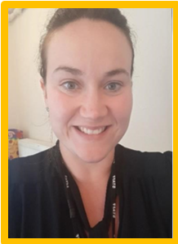
My name is Laura Potter. I am the acting SENCO of St Wilfrid’s Catholic Primary School. My role is to work with children, parents, teaching staff, school leaders and outside agencies to do everything we can to support children with Special Educational Needs and Disabilities.
The information report tells you about how the staff at St Wilfrid’s Catholic Primary School support children with Special educational needs and disabilities (SEND).

Contact details:
Phone: 0121 675 3319
Email: enquiry@stwilfrd.bham.sch.uk
At St Wilfrid’s Catholic Primary School we strive to support all our children and enable them to enjoy and achieve at our school. Quality teaching is vital, however for some children there are occasions when further additional support may be needed to help them achieve their targets.

The SEND Information Report aims to outline how the SEND Policy will be implemented within St Wilfrid’s Catholic J & I School and details the offer for SEND within St Wilfrid’s Catholic J & I School and ways in which parents, children and young people may access the support required.

This SEND information report is based on the statutory Special Educational Needs and Disability (SEND) Code of Practice and the following legislation:

• Part 3 of the Children and Families Act 2014, which sets out schools’ responsibilities for pupils with SEN and disabilities
• The Special Educational Needs and Disability Regulations 2014, which set out schools’ responsibilities for education, health and care (EHC) plans, SEN coordinators (SENCOs) and the SEN information report

What is SEND?

SEND refers to a learning difficulty or disability which calls for special educational provision to be made, for example, where a child has:
- a significantly greater difficulty in learning than the majority of others of the same age, or
- a disability which prevents or hinders them from making use of facilities of a kind generally provided for others of the same age in mainstream schools
Special educational provision is additional to, or different from, any provision made generally for other children or young people of the same age by mainstream schools.

Which SEND needs do we provide for at St Wilfrid’s?

At St Wilfrid’s we support children with a wide range of additional needs and are committed to the early identification and assessment of pupils to facilitate learning for all. Help and support can be provided for the following areas of need:
Area of need | What this could look like
  Cognition and Learning | This area includes general learning difficulties (which may be moderate or severe), profound and multiple learning difficulties (PMLD) and specific learning difficulties (SpLD).  SpLDs include: dyslexia (difficulties with reading and spelling), dyscalculia (difficulties with number and calculation), and dyspraxia (or ‘developmental coordination disorder’, difficulties with motor planning).
  Communication and Interaction | This area includes speech, language and communication needs  (SLCN), which could mean difficulties with speech production, the understanding of language, the expression of language or a combination of all three. It also includes difficulties with the social use of language.
  Social, emotional and mental health difficulties | This area includes children who find it difficult to manage their feelings and behaviour. Challenging behaviours are displayed for many reasons, which may be indicative of underlying mental health difficulties (such as anxiety or  depression), or emotional issues (such as disordered attachment). Some children have disorders such as ADHD (Attention Deficit Hyperactivity Disorder) or ADD (Attention Deficit Disorder) which affect how they behave.
  Sensory and Physical needs | This area includes sensory impairments, such as visual impairment (VI) and hearing impairment (HI), as well as physical disabilities such as cerebral palsy. Children with these disabilities will usually access support from the specific local team, which may be a combination of education and health services.

St Wilfrid’s School values the contribution that every child can make. We are committed to offering an inclusive curriculum to ensure the best possible progress for all of our pupils whatever their needs and abilities. All children with SEND are valued, respected and equal members of the school. Every effort is made to ensure that pupils identified as having SEND are fully integrated into mainstream classes. and have full access to the National Curriculum and after school activities.

As such, provision for pupils with SEND is a matter for the school as a whole.
“All teachers and key workers are teachers of pupils with SEN”.

How do we support pupils with SEND?

All school staff receive appropriate training so they have the knowledge and confidence to support children’s needs.
• Staff attend workshops on specific needs, including those organised by outside agencies.
• Teaching staff will be able to accurately assess the level children are working at and aim to differentiate the curriculum to meet the needs of your child.
• Your child will receive Quality First Teaching in class, where the class teacher will aim to provide the support your child needs through adapting the curriculum and providing carefully chosen resources. Further support may then be given through interventions to help support your child in a specific area and advice may be sought from Outside Agency Support Services, if appropriate.
• A record of all the support you child has received is kept by school to ensure that the support is the most effective for your child. This information is recorded on a provision map. Provision is reviewed and monitored regularly.
• Support for your child will be provided through matching the work within the classroom to their needs (Quality First Teaching), through small group work or one-to-one work, or through intervention programmes to target specific areas of learning, as appropriate.
• Adaptations can be made as appropriate to accommodate children with physical difficulties, hearing difficulties, or sight difficulties.
Details of this can be found in the school’s Accessibility Action Plan as part of our commitment to the Equality Act 2010.
• All pupils, including those with SEND are set targets as to the amount of progress they are expected to make. This is monitored regularly to ensure progress is good.
• Staffing arrangements are carefully considered to match the needs of individuals and staff specialisms/previous training are considered when identifying who will provide extra support for your child.
• Children will be assessed against the National Curriculum criteria or Pre-Key stage levels, as appropriate. Staff will receive training in this and school will continue to be moderated to ensure accurate assessment.
• Please also refer to the school’s curriculum and assessment policies.

This support follows a graduated approach (also known as ‘Assess, Plan,
Do, and Review’) as outlined in the revised SEN Code of Practice 2015

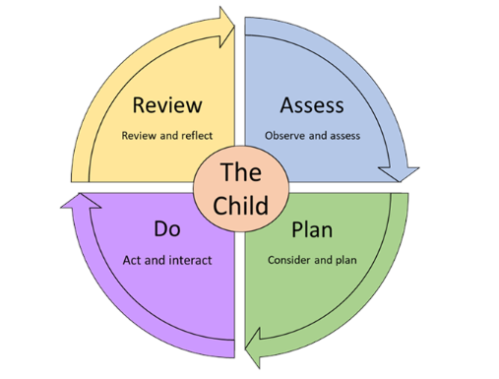

We employ a tiered approach to intervention.

📘 Universal
Teachers plan to meet the needs of all pupils by ensuring learning is focussed on individual pupils needs, abilities and potential.

🎯 Targeted
Some children require more support than the Universal level in order to make appropriate progress. This type of intervention is over and above that provided through differentiated classroom teaching and should be specific work targeted at meeting their identified needs.

Wave Three - 🧠 Specialist
For those children with more complex special educational needs, there may be the need for individual targets and specialised support. Outside agencies may be consulted (with parental permission) to support school in ensuring the best outcomes for pupils. Where this is the case, parents are invited to regularly review targets termly with the class teacher and or the SENCo, and set new ones as appropriate.
In some cases, after reviewing the targets and outcomes, it may be necessary to move a pupil further on within the ‘SEN Support’ category to a Send Support Provision Plan (SSPP) or and Educational Health Care Plan (EHCP) This is reviewed annually, and progress carefully monitored.

More information about EHCP’s can be found on the Birmingham local offer link: https://www.localofferbirmingham.co.uk/education-health-and-care-plan/

The school will involve you and your child in all decisions and listen to your views surrounding your child’s area of difficulty or the support which they are receiving.
In our school, if we feel a pupils needs more specialist help we can work with the following people:

- CAT (Communication and Autism) Team: Cari-Anne O’Brien
- LLSS (Language, Learning and Strategic Support): Natalie O’Brien
- West Midlands Speech and Language therapy: Ellie Hinchcliffe
- Birmingham Educational Psychologist: Fran Weir
- Occupational Health team (NHS) – as required
- Community Paediatrician
- Forward Thinking Birmingham (CAMHs)

Once a child has been identified as requiring more support the next steps are as follows:
Parents are contacted to arrange a meeting with to discuss concerns raised;
The year group looks at available provision and, where appropriate, the child joins an intervention group with targeted outcomes in the hope to close the gap which has occured;
If the intervention does not produce the outcomes required, then the SENCo would be informed and advice about appropriate interventions would be discussed and put into place;
If progress is still limited then a referral would be made, with the consent of the child’s parents, to an outside agency as listed above.
Once the child has been assessed by a professional from an outside agency a report would be created and given to the SENCo who would ensure that this is shared with class staff and parents.
The appropriate interventions then take place and the child is monitored by the SENCo and, where necessary, the outside agency again at a later date.

At St Wilfrid’s we ensure there is appropriate provision for pupils with special educational needs whether or not the pupil has an Educational Health Care Plan (EHCP).

For those children with more complex needs, a referral, with permission from parents, may be placed to Forward Thinking Birmingham (children’s mental health services).

Working together…

We will work in partnership with you to identify the needs of your child and ensure that the correct support is in place, including family support if required.
You will be invited to attend review meetings, or asked to meet with a member of the Outside Agency Support team who is working with your child, to review their progress and the support that is in place, if this is appropriate. Your child will also be asked to contribute to the review of their targets and to their one page profile as appropriate.
We may also carry out observations of your child working within the classroom to further our understanding of their difficulty.
This will involve looking at your child’s work and talking to your child about what they are doing and how they feel when working in class.
These observations and discussions ensure that we know your child well, including their interests and strengths, as well as the support they require.

Pastoral Support
At St Wilfrid’s we have a high level of support available for improving the emotional, mental and social development of pupils with special educational needs, as well as those who do not have special educational needs.
Children who need time to talk about their emotions have access to trained staff for support.
Our Pastoral Manager is Ms Sherelle Donald. She provides support and information to families. An appointment can be made with her through the school office or email at enquiry@stwilfrd.bham.sch.uk
Our pastoral TA/Mentor is Ms Paula Byrne-Mullen, who works with and supports children who find the social aspects of school a challenge, she ensures they are given the opportunity to take part in social groups with role models to support appropriate social behavior and to build self esteem.
SEND Governor
The SENCO regularly informs the governing body about SEND progress, training and work with our partners. Our SEND Governor is Mr Matt Sparling.

School adheres to the Children and Families Act 2014 which includes changes to the support for children with Special Educational Needs & Disabilities (SEND). This document named “0-25 Special Educational Needs and Disabilities Code of Practice” sets out how schools support children with SEND. Local authorities must publish a Local Offer, setting out in one place information about provision that is available and provision that is expected to be across education, health and social care for children and young people in their area who have special educational needs and disabilities (SEND).

You can find more information about Birmingham’s local offer by visiting the following website: https://www.localofferbirmingham.co.uk

You asked…We said….

How will my child be included in activities outside the classroom including school trips?
Risk assessments are carried out and procedures are put in place to enable all children to participate in all school activities.
The school ensures it has sufficient staff expertise to ensure that no child with SEND is excluded from any school provided activity.
How accessible is the school environment?
See the accessibility plan. This is a 2-story building with 2 lifts for access to both floors.
Disabled parking spot marked and located near to the school reception;
There are no steps entering the building to ensure access to all;
Two toilets have been adapted to ensure accessibility for visitors with a disability;
A lift to access upstairs.
Wide corridors and doorways into classrooms ensure maximum accessibility.
How will the school prepare/support my child when moving classes or joining or transferring to a new school?
A number of strategies are in place to enable effective pupils’ transition. These include:
On entry:
A planned introduction programme is delivered in the Summer term to support transfer for pupils starting school in September.
Parents/carers are invited to a meeting at the school and are provided with a range of information to support them in enabling their child to settle into the school routine.
The SENCo meets with all new parents of pupils who are known to have SEND to allow concerns to be raised and solutions to any perceived challenges to be resolved prior to entry.
If pupils are transferring from another setting, the previous school records will be requested immediately and a meeting set up with parents to identify and reduce any concerns.
Secondary transition
The transition programme in place for pupils provides a number of opportunities for pupils and parents to meet staff in the new school. These opportunities are further enhanced for pupils with SEND who have access to additional visits to their secondary school.
The annual review in Y5 for pupils with an EHCP begins the process where parents are supported to make decisions regarding secondary school choice.
Parents will be encouraged to consider options for the next phase of education and the school will involve outside agencies, as appropriate, to ensure information provided is comprehensive but accessible.
Accompanied visits to other providers may be arranged as appropriate.
For pupils transferring to local schools, the SENCos of both schools will meet to discuss the needs of pupils with SEND in order to ensure a smooth transition.

The records of pupils who leave the school mid-phase will be transferred within five working days of the parents notifying their child has been enrolled at another school.

Further support for families of children with SEND.

There are many support services available for parents with children with special educational needs and some of these can be found below:
SENDIASS offer independent advice and support to parents and carers of all children and young people with SEND.
https://www.birmingham.gov.uk/SENDIASS
⚖️ Complaints
SENDIAS will also provide information on how to access an Independent Supporter for those parents whose children are being assessed for an EHCP. Independent Supports aim to provide guidance to parents regarding the EHCP process. A FAQ fact sheet on Independent Supporters is located here https://preview.tinyurl.com/ox2q3cv
For parents who are unhappy with the Local Authority or school responses to the child’s SEND, parents may seek mediation from the regional mediation services. Information on this free service is located here http://preview.tinyurl.com/qx5a8vq
Parents and carers can also appeal to the Government’s SEND tribunal if you disagree with the Local Authority’s decision about your child’s special educational needs. You can also appeal to the tribunal if the school or council has discriminated against your disabled child. Information on this process is available here http://preview.tinyurl.com/ovq4so3

Birmingham Local Authority local offer can be found at:
https://bham.sfedev.co.uk

If you have any questions or concerns then please contact the school SENCo by:

Phone: 0121 675 3319
Email: enquiry@stwilfrd.bham.sch.uk

Sometimes the language of SEND is difficult to understand as everyone uses lots of abbreviations. The table below outlines the abbreviation and its meaning, we hope this helps. A more comprehensive glossary of terms is included in the appendices of the SEND Code of Practice.
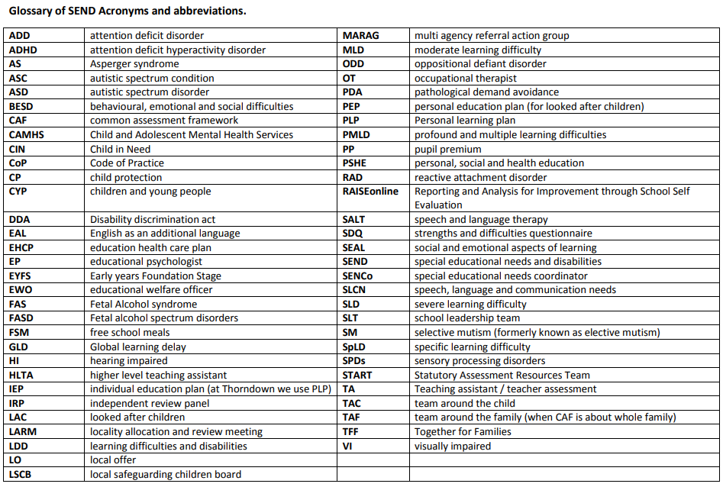

SIR reviewed: October 2026
SIR next review: October 2027

